Data MANIPULATION Languages (DML)
1. Perform UNION of customers and employees relation. (i.e. only matching
attributes)
Query:

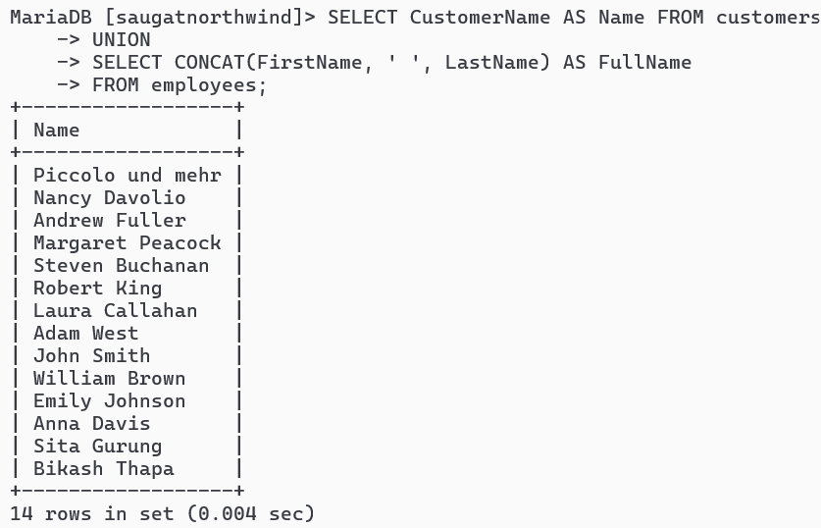
2. Perform UNION ALL of customers.contactname and employee.fullname
Query:

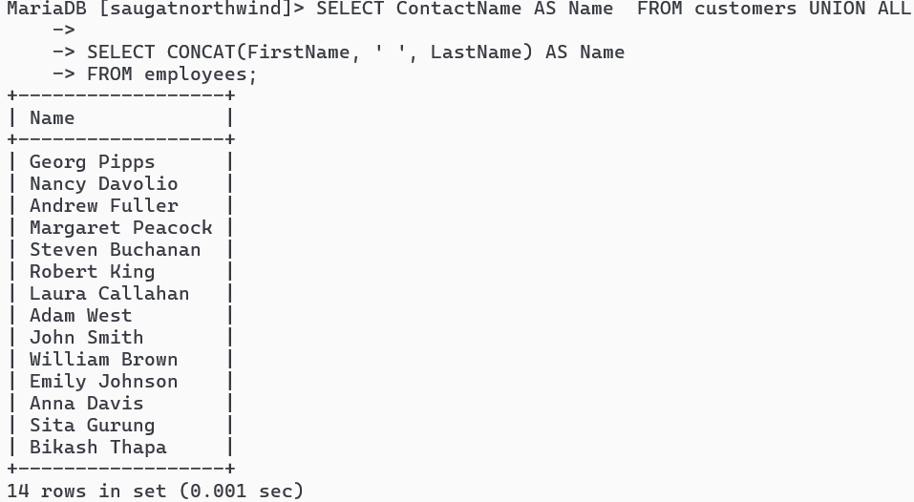
3. List all customers from Berlin, Germany and Paris France using UNION
Query:

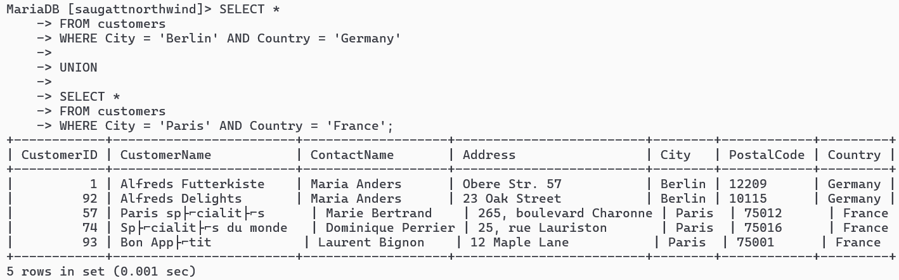

4. List all customers of USA not having same name as of customers from UK
Query:

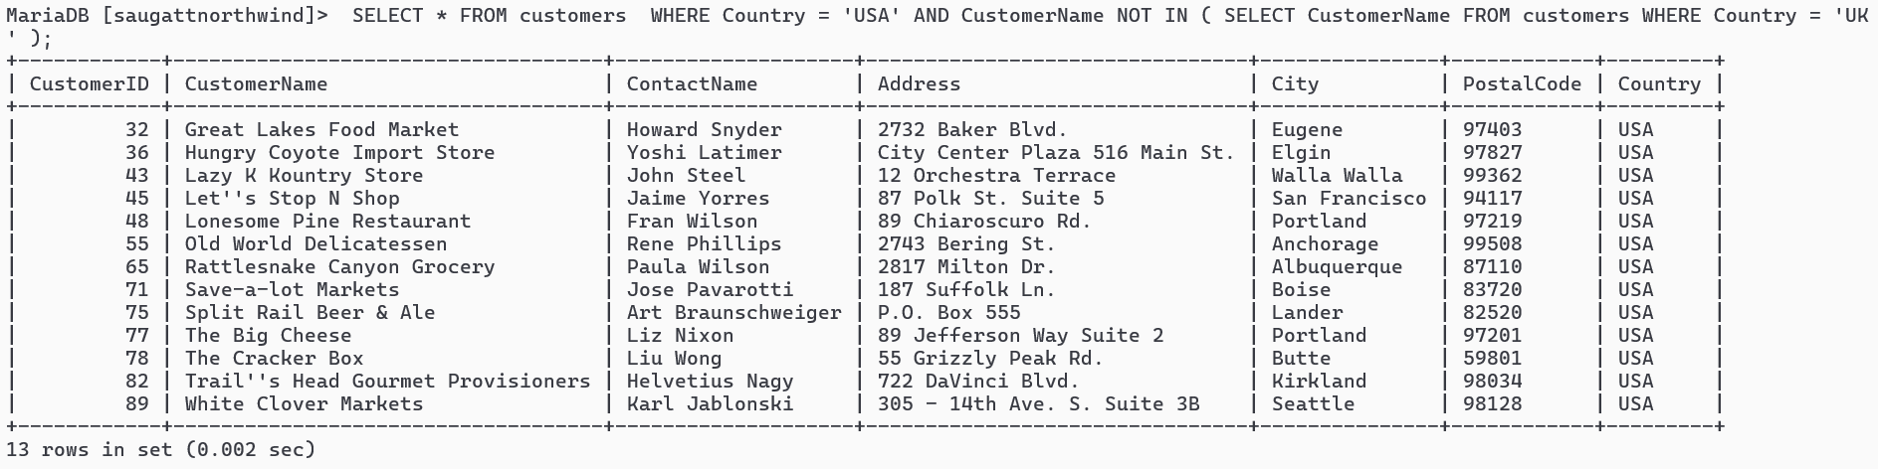

5. Create view cust by selecting only 4 attributes from customers
Query:

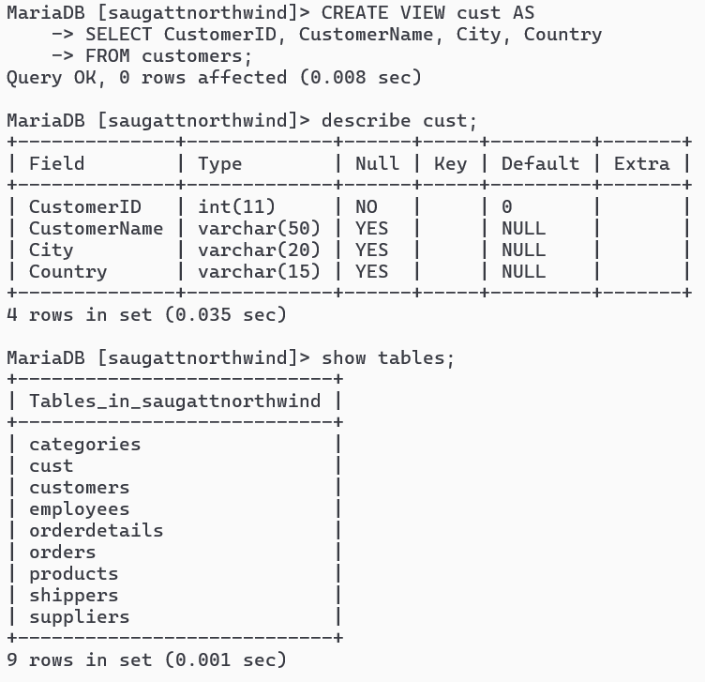
6. Join Products with Categories and Suppliers to create a view named
productinfo with ID,Name,Unit, Price from products and all attributes
from categories and suppliers
Query:

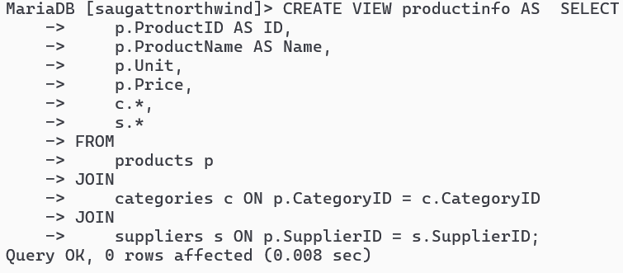

7. Find name and count of Categories from productinfo
Query:

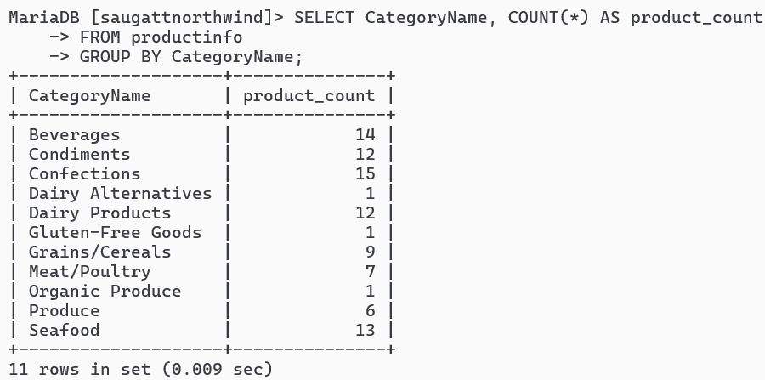
8. Find all products that have suppliers from Asia in productinfo
Query:

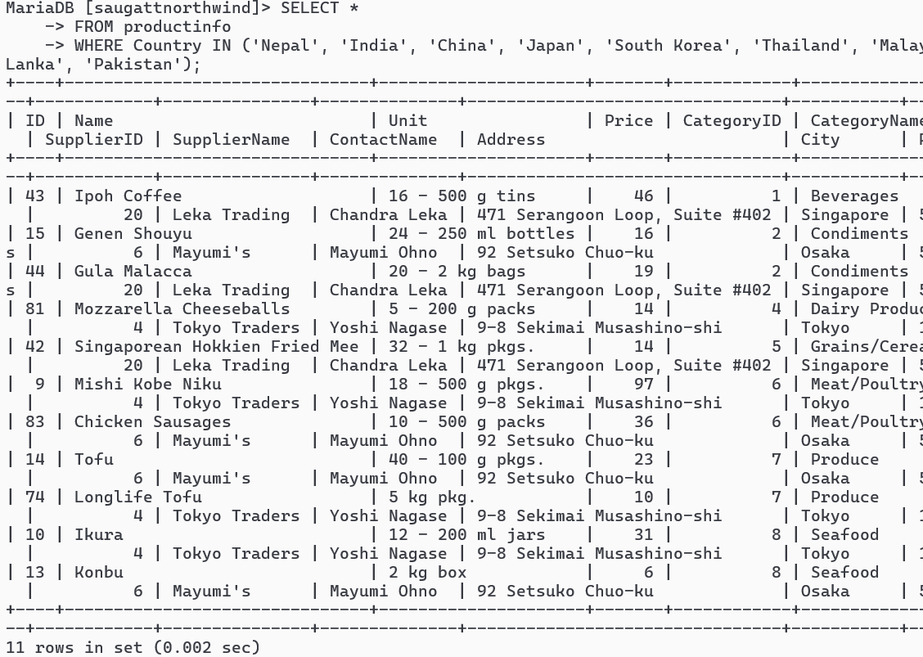
9. Find all products that have price lower price than Average price from
Productinfo
Query:

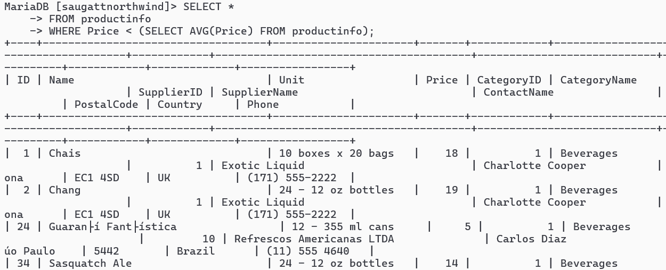
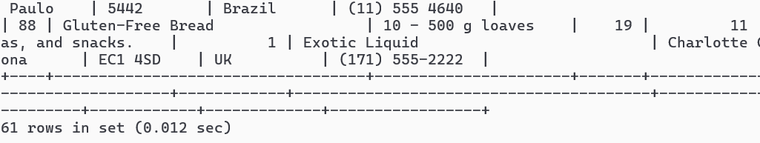
10. Join orders with customers, employees and shippers to create a view as
Orderinfo
Query:

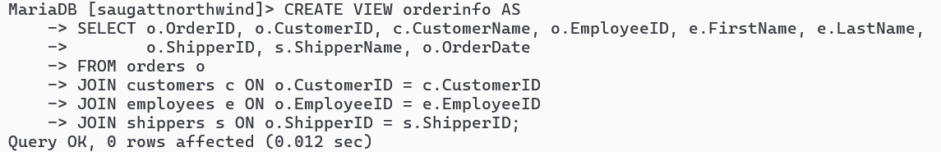
11. List all order shipment provided by Speedy Express and Global Express
from orderinfo
Query:

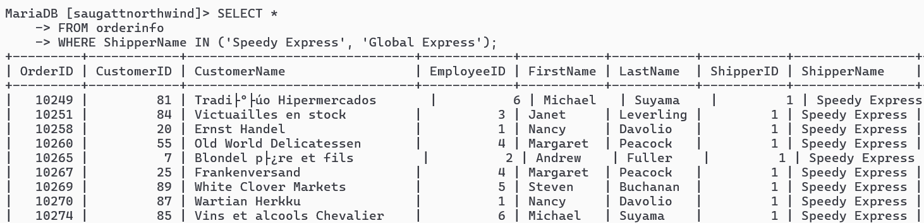
12. List all order processed by employee Nancy Davolio and Michael Suyama
from orderinfo
Query:

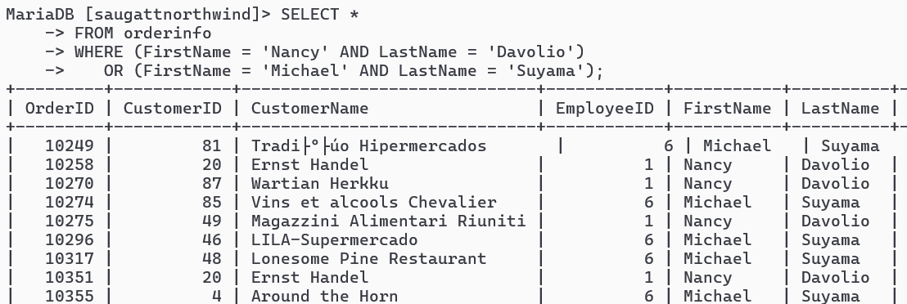
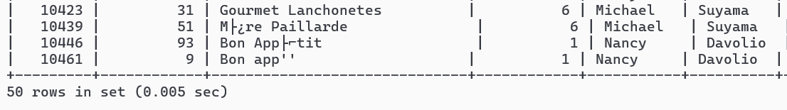
13. List all order shipment provider on date august 19 2023 from orderinfo
Query:
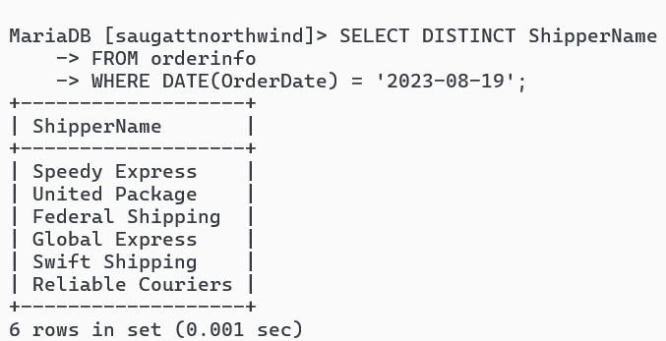
14. List countries of customers that placed order on august 17 2023 from orderinfo
Query:

